DEPLOY PYTHON WEB APPLICATIONS USING GIT, AWS SERVICES

INTRODUCTION

what is flask

flask is a small and lightweight python web framework that provides useful tools and features that make creating a web application in .py easier.

it gives developers flexibility and is the more accessible framework for new developers since you can build a web application quickly using only a single python file.

What is python

Python is a computer programming lang. often used to build websites and software to automate tasks and conduct data analysis.

What is PIP?

PIP is a package manager for python packages or modules.

NOTE: if your python version 3.4 or later, PIP is included by default

PIP: package installer for python.

PRE-REQUISITES:

1. AWS account (Root account)

2. IAM USER

3. TERMINAL

AWS Services &Tools:

* I AM
* VPC
* EC2
* ROUTE 53

DevOps tools

* GIT
* GITHUB
* JENKINS

Step-by-step procedure:

Create and log in to the AWS root account.

creation and login to the IAM user from the root user account along with EC2 full access, admin access, and programmatic passwords

Create a customized virtual cloud network along with SN s RT s IGW, SG s Eip, and NACl.

Create SG with respective ports.

SSH-22 (Replace with 22) for a secure connection.

HTTP-80

HTTPS-443

TCP- 8000,8080,9000

**Module – 1: Now Creating and launching an Amazon Ubuntu EC2 instance**

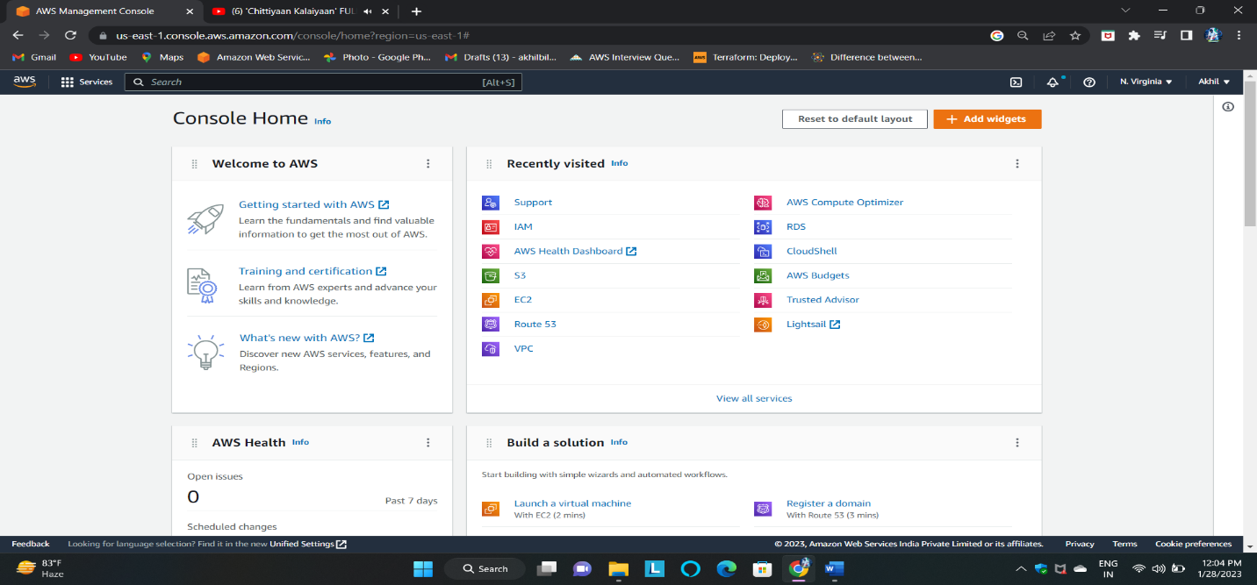EC2: Amazon Elastic Compute Cloud (Amazon EC2) provides scalable computing capacity in the Amazon Web Services (AWS) Cloud. Using Amazon EC2 eliminates your need to invest in hardware upfront, so you can develop and deploy applications faster.

# 2. Choosing an AMI – With Ubuntu

* An AMI is a virtual image used to create a virtual machine within an EC2 instance.
* 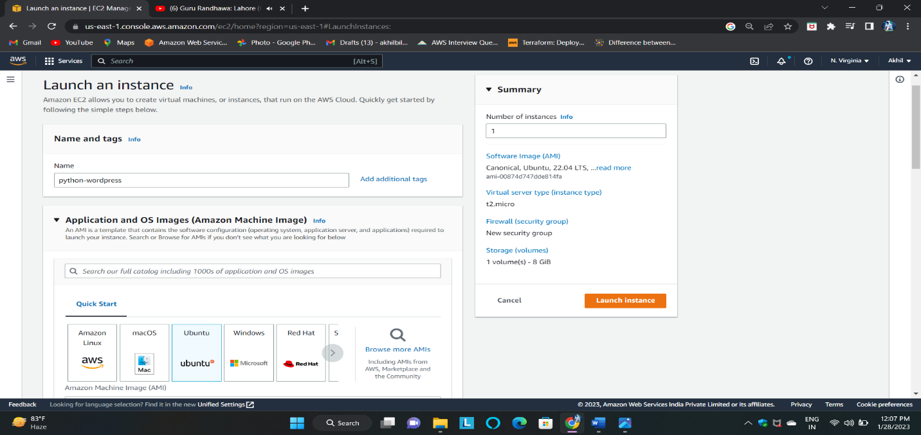You can also create multiple instances using a single AMI when you need instances with the same configuration.

1. **Select an Existing keypair or create a new key pair.**

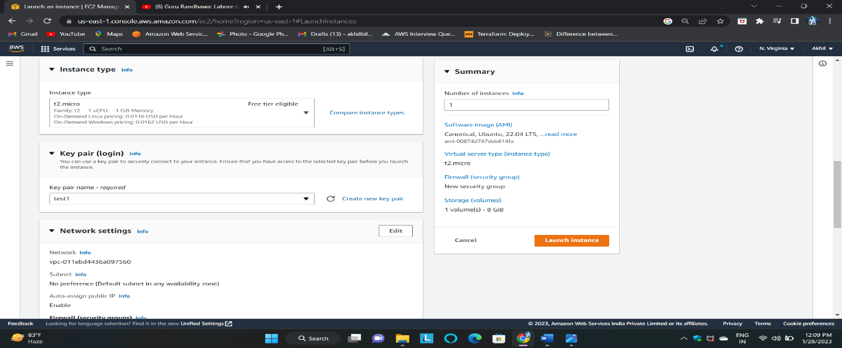A security group is a set of firewall rules that control the traffic for your instance. On this page, you can add rules to allow specific traffic to reach your instance. For example, if you want to set up a web server and allow Internet traffic to reach your instance, add rules that allow unrestricted access to the HTTP and HTTPS ports. You can create a new security group or select from an existing one below .

1. Configure the Security Group

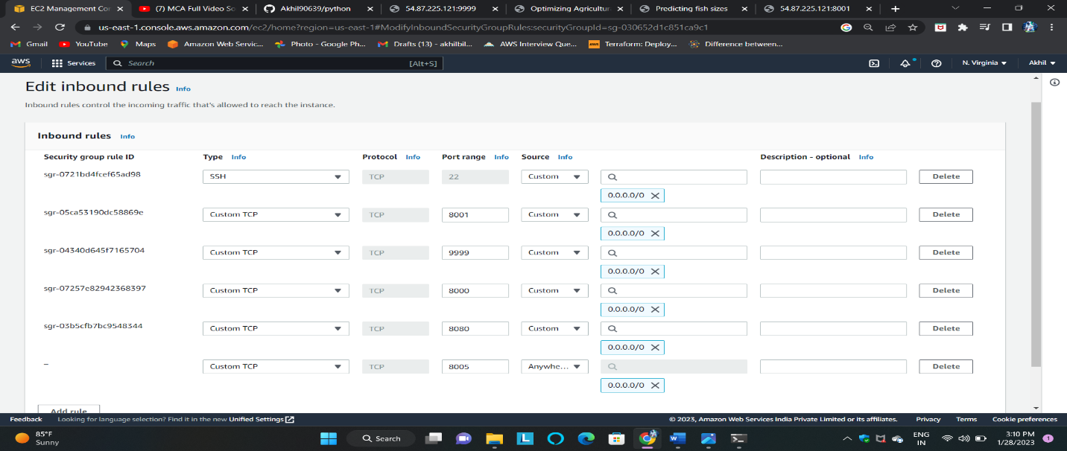Here, I am assigning the port numbers for the inbound rule SSH-22, 9999,8080,8000,8005,8001, and All Traffic for the outbound rule.

1. Finally, the Instance launched an Instance. Now to connect an EC2 instance we c

* 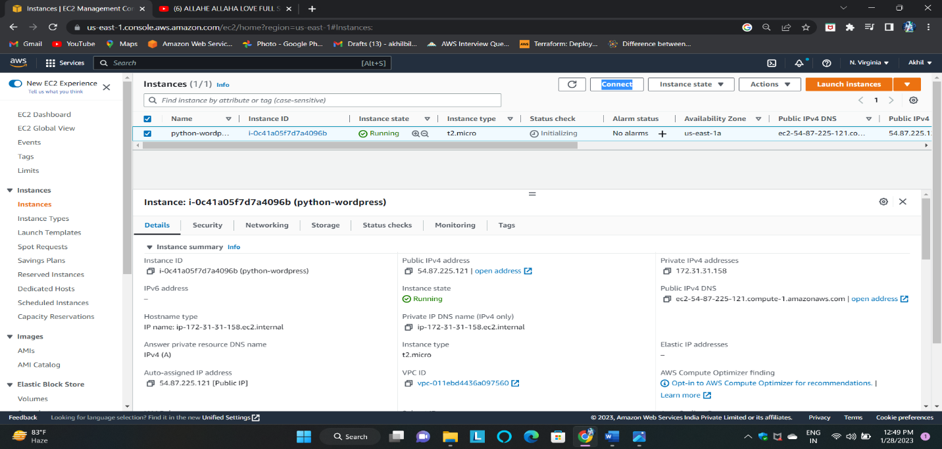Now to the instance page and click on connect then go to SSH Client/EC2 instance c
* 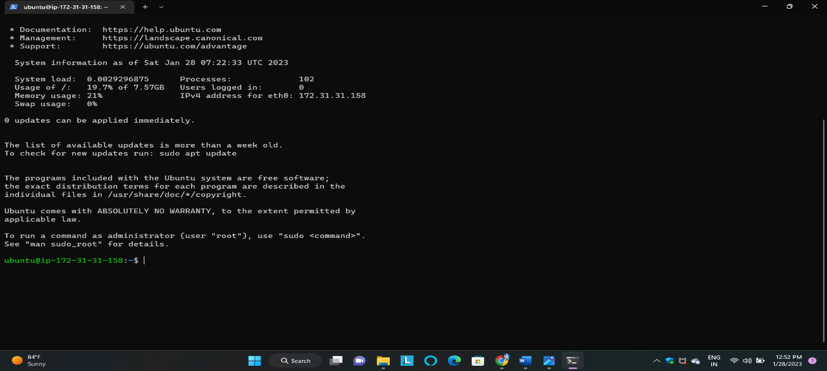By using the SSH command we are accessing our instance in Command Line Interface Terminal.

1. Update you are ubuntu machine by using this command.

* 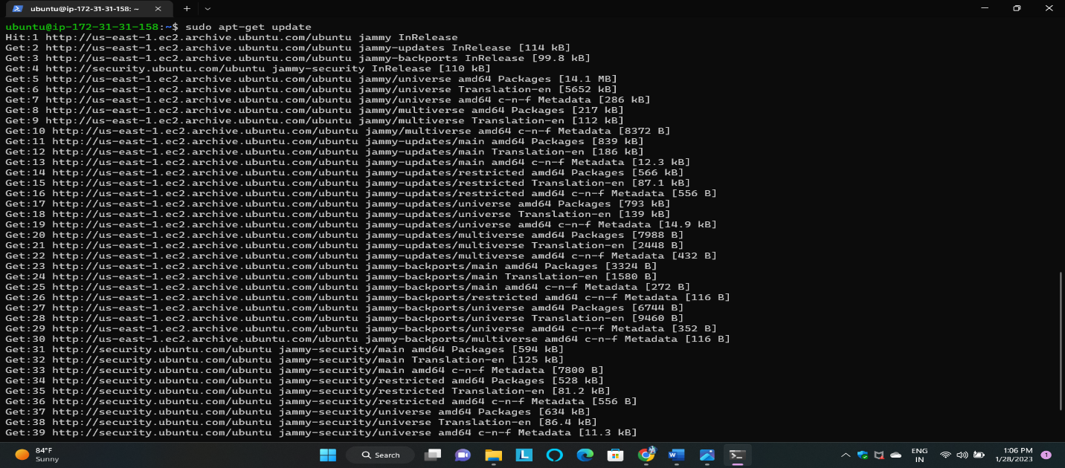sudo apt-get update

1. Install required packages/tools related for deploy the project. Using these commands.

* Install python by using this command.

* 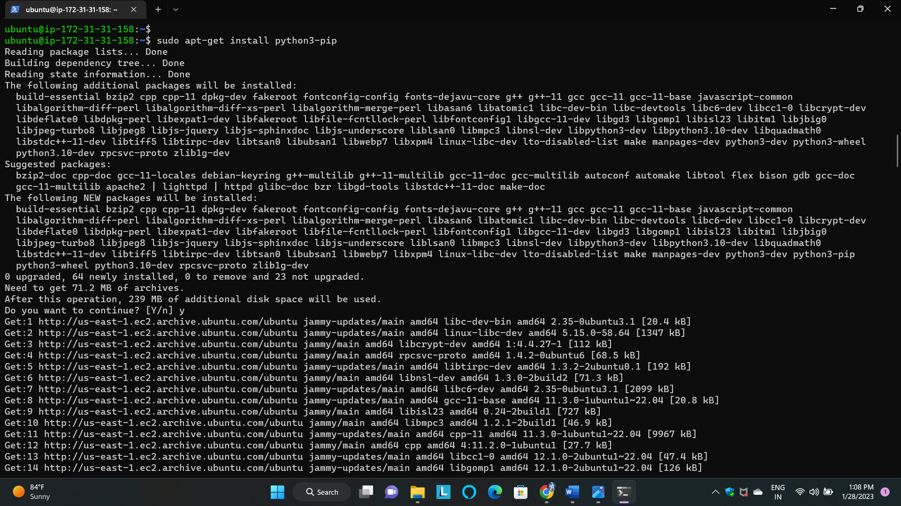sudo apt-get install python3-pip

1. Clone the project source code from the git hub to your machine (ubuntu machine)

* sudo apt install git
* 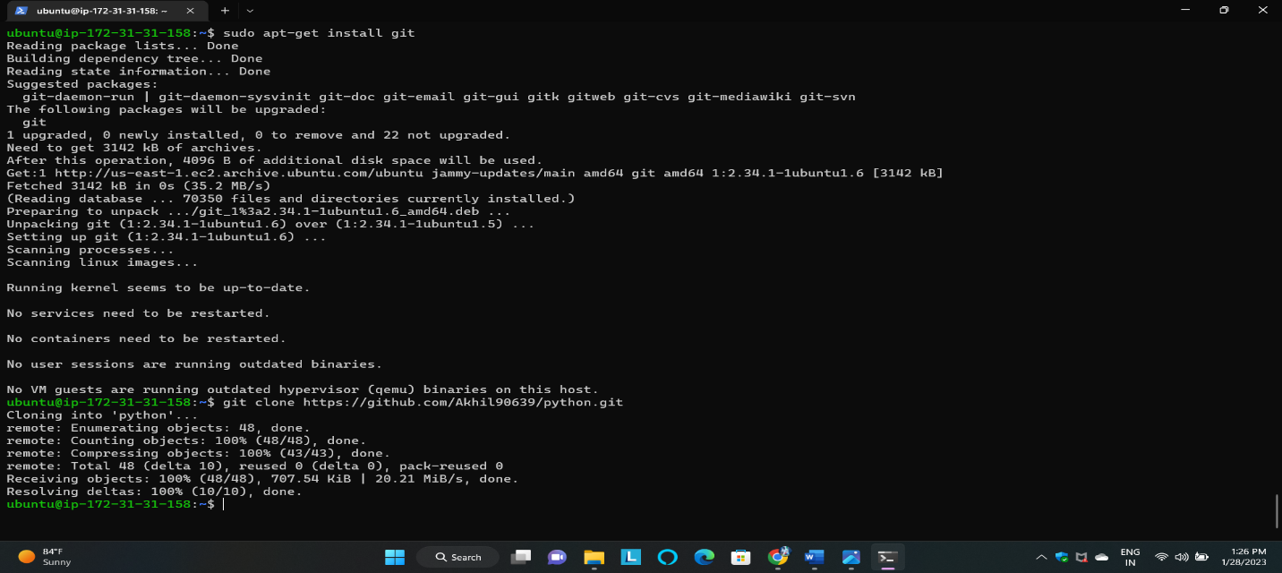git clone <https://github.com/Akhil90639/flask-app.py.git>
* Now, go to the source code directory

* cd python
* Now install requirements packages by using this command.
* 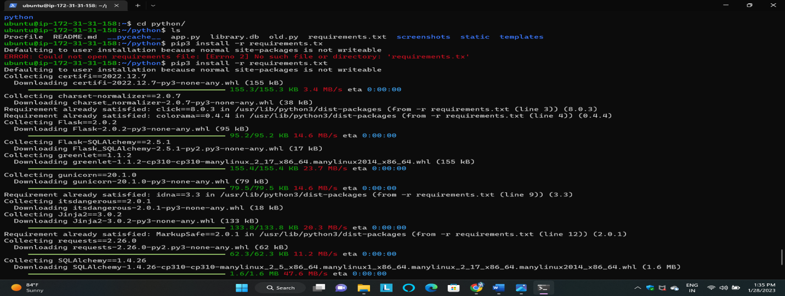pip3 install -r requirements.txt
* Here, after running python3 app.py it will generate a localhost IP address we can't access the web app with that IP address. then here we want to edit the file app.py with some details
* sudo vi app.py
* Go to the file and paste this text and save the file.

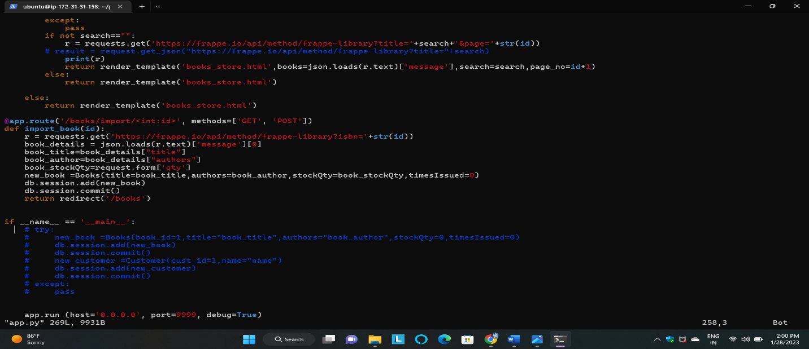 app.run(host='0.0.0.0', port=9999, debug=True)

* Now Run the flask server by using the below command
* python3 app.py

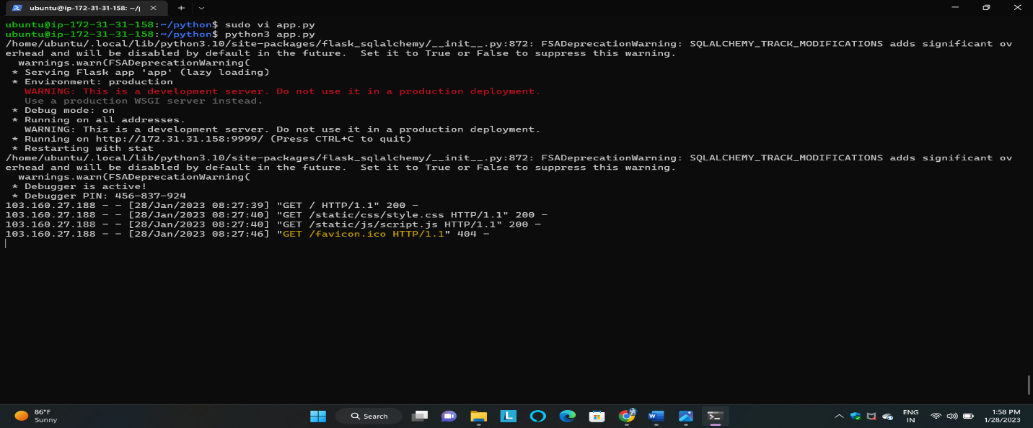

* 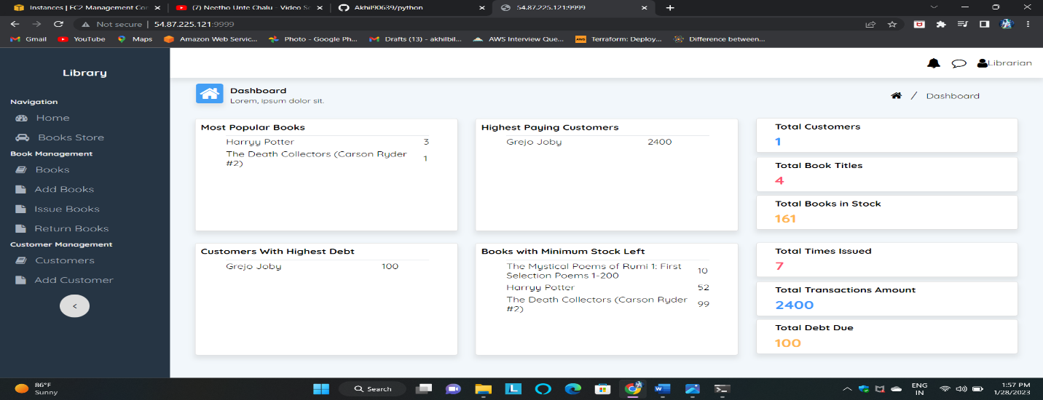Now copy your EC2 instance public IP and give the port number and search in the web browser
* Similarly deploy another application by using the below command.
* Clone the python application code.
* git clone <https://github.com/kallasrikanth1999/Agri.git>
* sudo vi app.py
* go to the file and paste this text and save the file.

app.run(host='0.0.0.0', port=8080, debug=True)

Now run the flask server by using the below command.

* 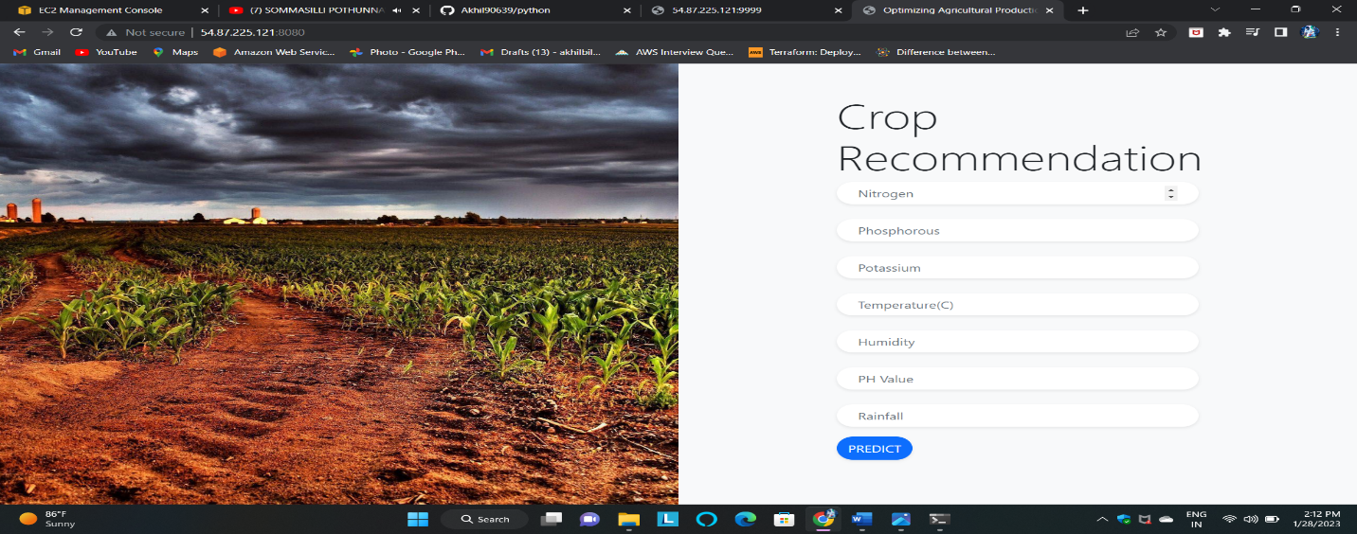python3 app.py
* Similarly deploy another application by using the below command.
* Clone the python application code.
* git clone <https://github.com/Akhil90639/fish.git>
* go to the file and paste this text and save the file.
* sudo vi app.py

app.run(host='0.0.0.0', port=8000, debug=True)

* Now run the flask server by using the below command.
* 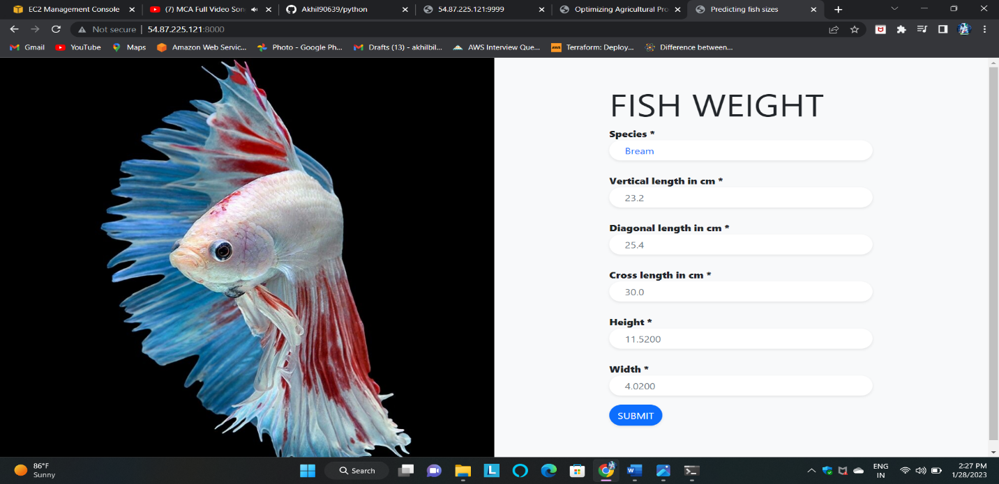python3 app.py
* Similarly deploy another application by using the below command.
* Clone the python application code.
* git clone <https://github.com/Akhil90639/indian-liver-patients.git>
* go to the file and paste this text and save the file.
* sudo vi app.py

app.run(host='0.0.0.0', port=8001, debug=True)

Now run the flask server by using the below command.

* python3 app.py

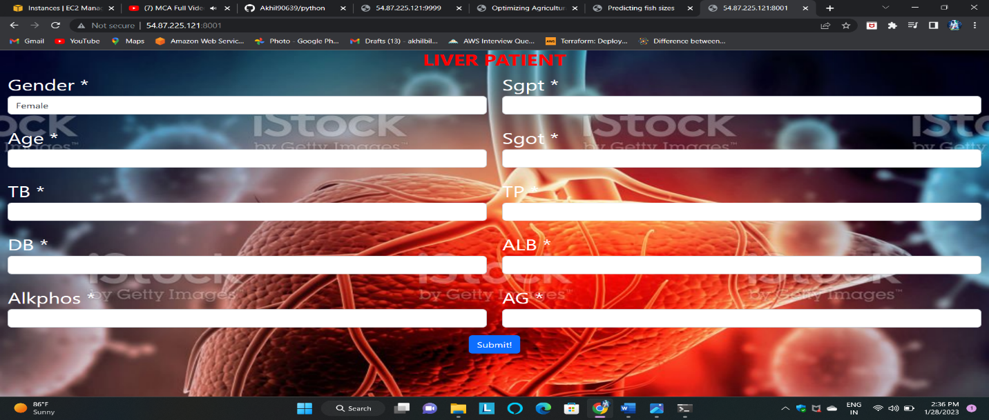

* Clone the python application code.
* git clone <https://github.com/Akhil90639/flight-perdiction.git>
* go to the file and paste this text and save the file.
* sudo vi app.py

app.run(host='0.0.0.0', port=8005, debug=True)

Now run the flask server by using the below command.

* python3 app.py